ASSIGNMENT 2  CONNECTING 2 LAN NETWORKS | Name: Nivetha Dhanakoti  Reg no.: 3122 22 5001 087

Aim:
Network Setup
Using Cisco Packet Tracer tool, establish a two simple LAN network. The two networks are connected to a switch. These two switches are connected via a router to connect two LANs.

Network:
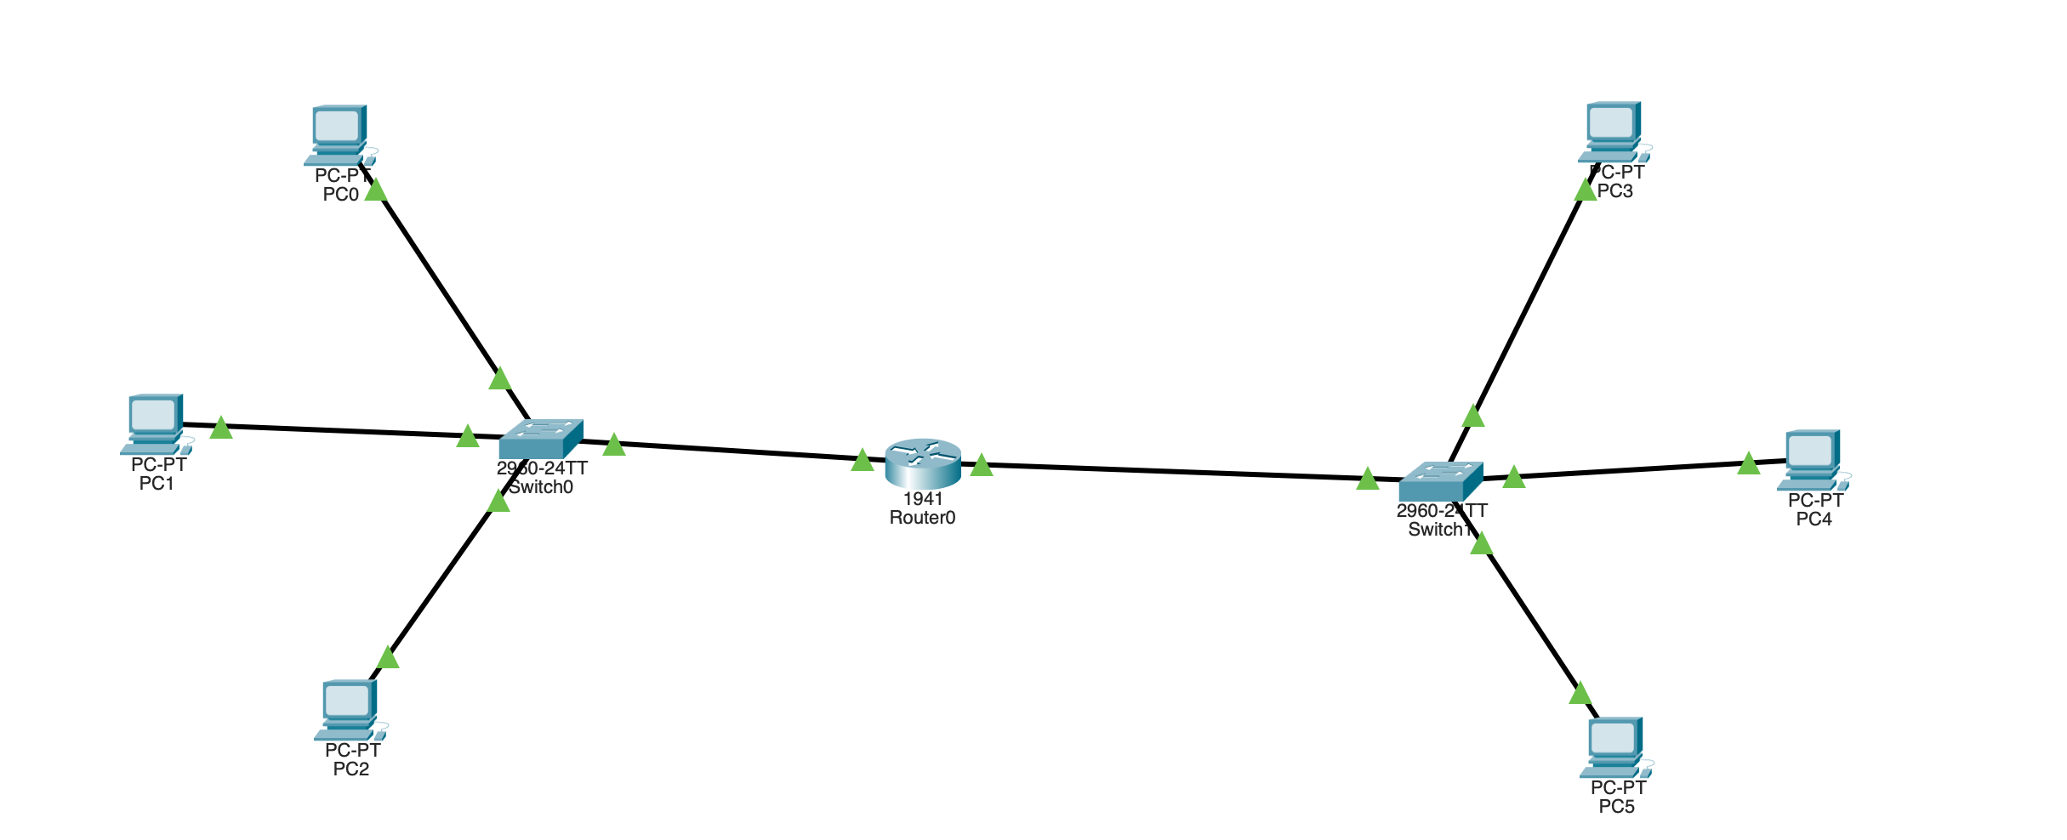

Working:

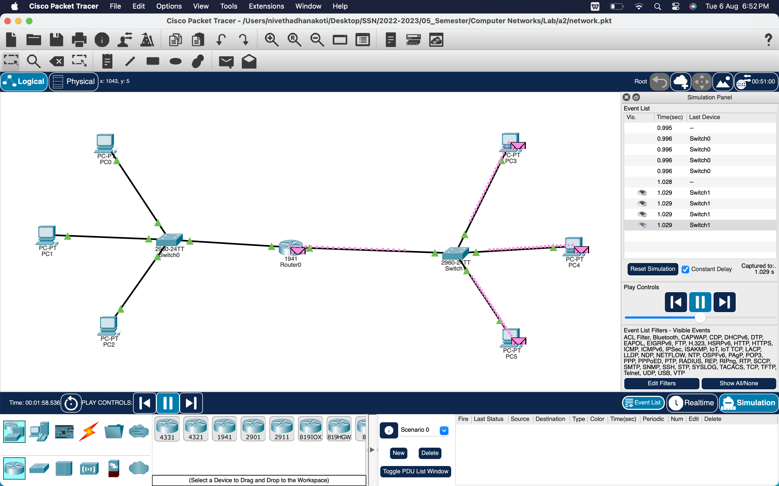
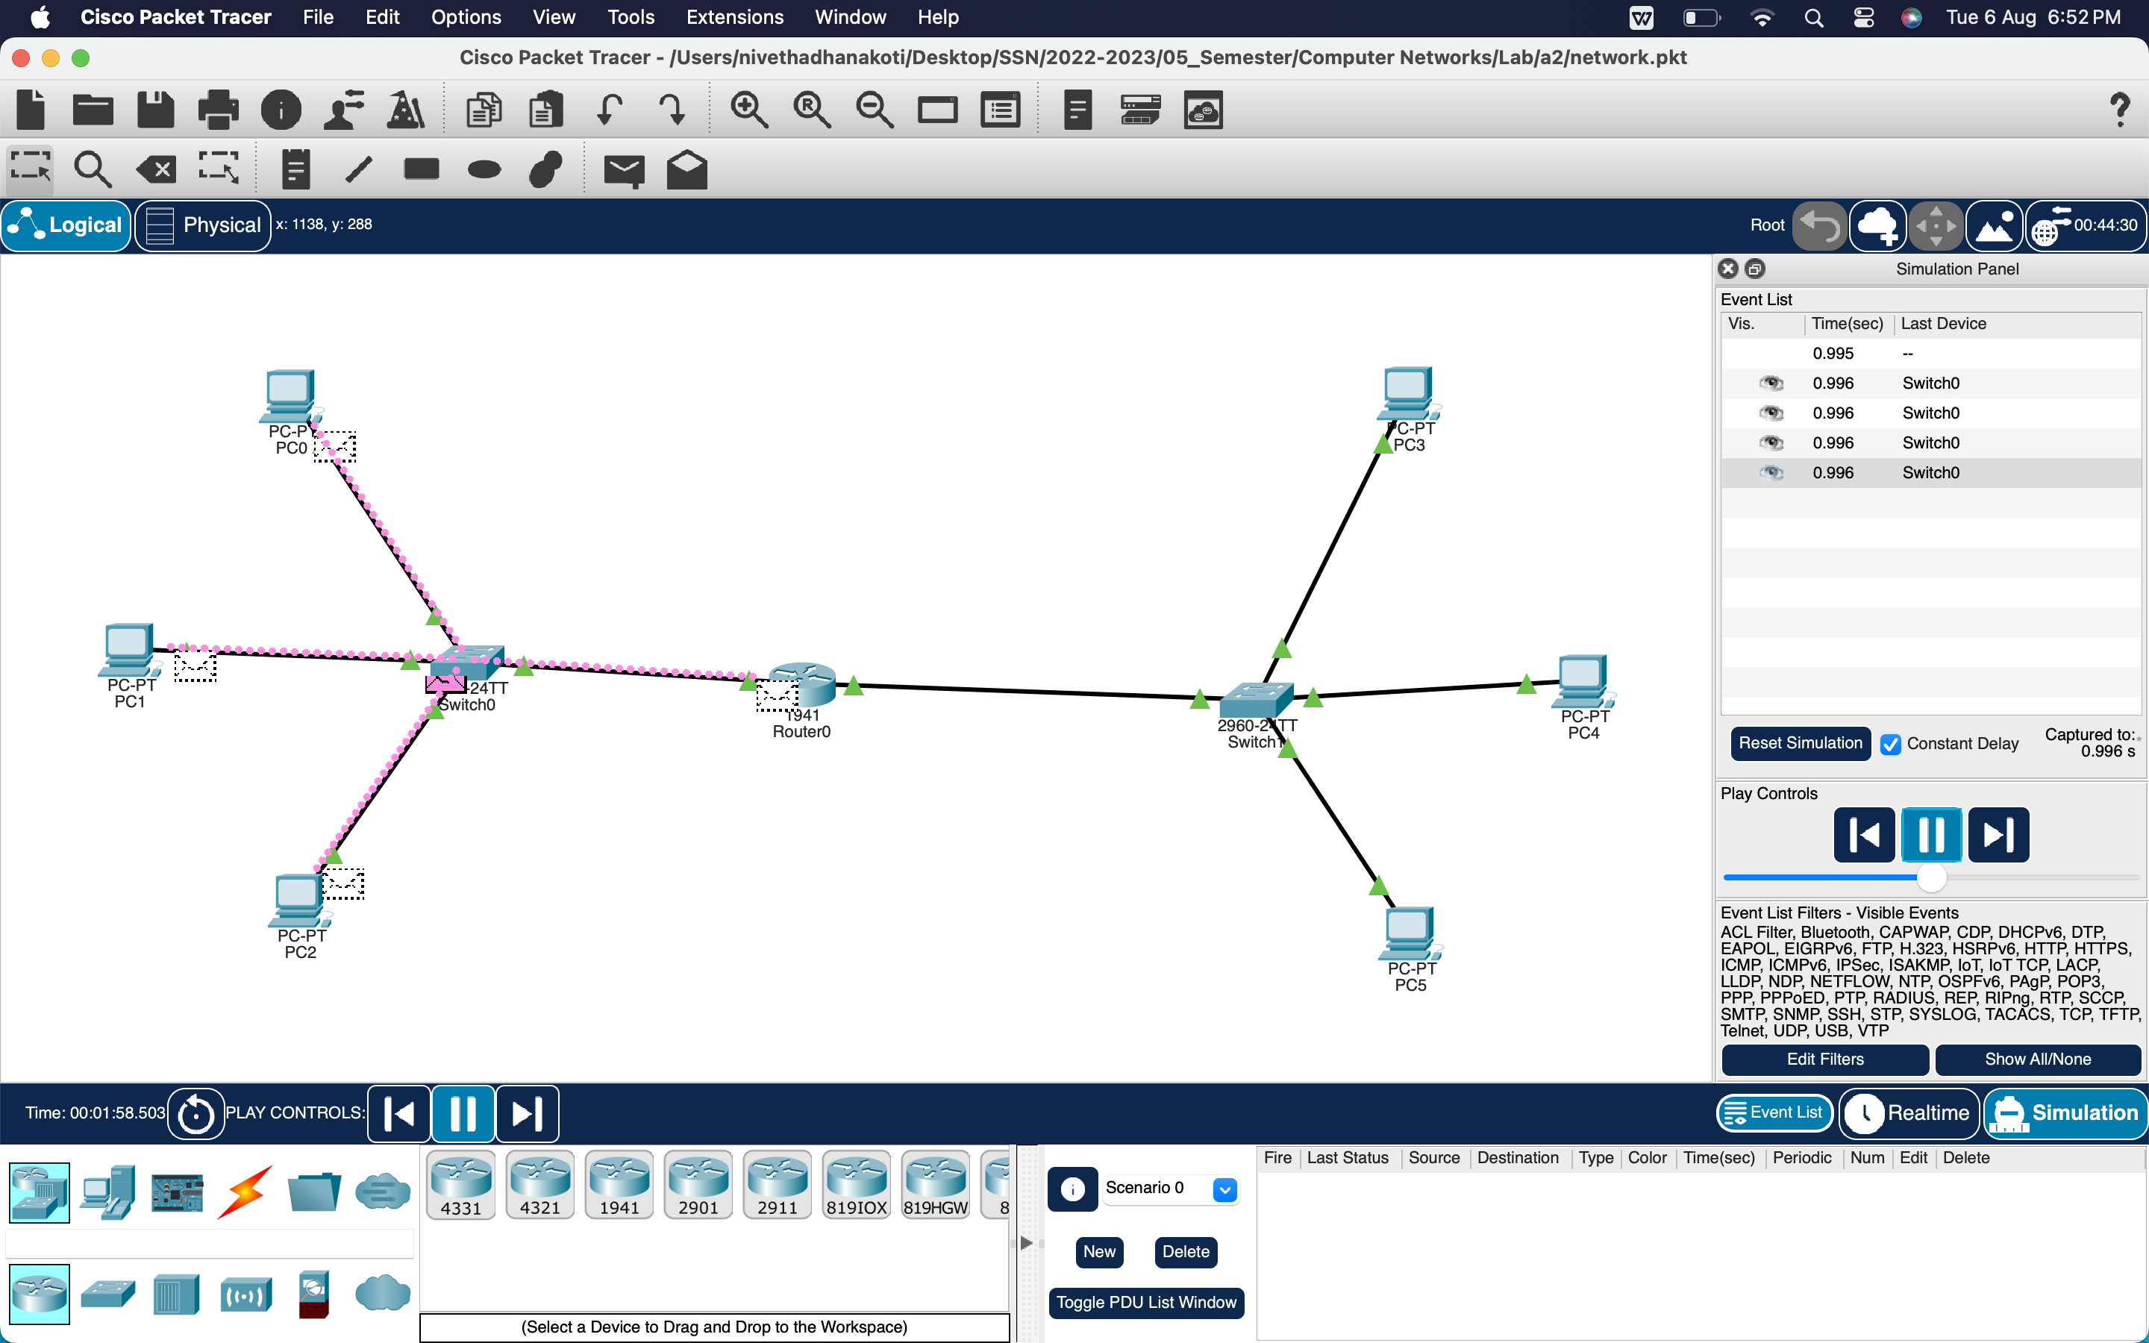

Learning Outcomes:
I have learntTo be proficient in establishing a LAN connection and to connect two LANs together.

